
JOBINK LOCAL JOBS PLATFORM
IET PROJECT
Submitted in partial fulfilment of the requirements for the
award of the degree of

BACHELOR OF SCIENCE
in
Computer science with Cognitive System
Submitted by

SRIMURUGAN S

Under the Guidance of
Assistant Professor
Deepa B
Department of IT and Cognitive System


SRI KRISHNA ARTS AND SCIENCE COLLEGE
COIMBATORE – 641008
JULY 2026


SRI KRISHNA ARTS AND SCIENCE COLLEGE
(Affiliated to Bharathiar University, Kuniamuthur, Coimbatore - 641008)

CERTIFICATE

This is to certify that the IET Project report entitled “ JOBINK LOCAL JOBS PLATFORM ” in partial fulfilment of requirements for the degree of Bachelor of Science in Computer Science with Cognitive System is a record of bonafide work carried out by SRIMURUGAN S and that no part of this has been submitted for the award of any other degree or diploma and the work has not been published in popular journal or magazine.

GUIDE HOD & DEAN

This IET Report is submitted for the viva voce conducted on __________________ at Sri Krishna Arts and Science College.

INTERNAL EXAMINER EXTERNAL EXAMINER

SRI KRISHNA ARTS AND SCIENCE COLLEGE
(Affiliated to Bharathiar University Kuniamuthur, Coimbatore - 641008)

DECLARATION

I hereby declare that the IET Project report entitled “JOBINK LOCAL JOBS PLATFORM ” submitted in partial fulfilment of the requirements for the award of degree of Bachelor of Science in Computer Science with Cognitive System is an original work and it has not been previously formed the basis for the award of any Degree, Diploma, Associate ship, Fellowship or similar titles to any other university or body during the period of my study.

Place: Coimbatore

Date:

Signature of the Candidate
SRIMURUGAN S

ACKNOWLEDGEMENT

I am ineffably indebted to Dr. K. Sundararaman, M.Com., M.Phil., Ph.D., CEO, Sri Krishna Institutions, Sri Krishna Arts and Science College, Coimbatore.
I convey my profound gratitude to Dr. R. Jagajeevan MBA., Ph.D., Principal, Sri Krishna Arts and Science College for giving me this opportunity to undergo this Capstone Project work.
It is my prime to solemnly express my sense of gratitude to Dr. K. S. Jeen Marseline, M.C.A., M.Phil., Ph.D., Head and Dean, Department of IT & Cognitive Systems, Sri Krishna Arts and Science College.
I would like to extend my thanks and unbound sense for the timely help and assistance given by Mrs. Deepa B ., Assistant Professor, Department of IT & Cognitive Systems, Sri Krishna Arts and Science College in completing the Capstone Project work. Her remarkable guidance at every stage of my work was coupled with suggestion and motivation.
I take this opportunity to thank my parents and friends for their constant support and encouragement throughout this training.

SRIMURUGAN S



TABLE OF CONTENTS
CHAPTER NO. | CHAPTER TITLE | PAGE NO.
1 | ORGANIZATION PROFILE | 7
2 | PROBLEM STATEMENT | 8
3 | SYSTEM STUDY | 10
 | 3.1 EXISTING SYSTEM | 10
 | 3.2 PROPOSED SYSTEM | 11
 | 3.3 SOFTWARE AND HARDWARE REQUIREMENTS | 12
4 | DESIGN | 14
 | 4.1 DATA FLOW DIAGRAM | 14
 | 4.1.2 ER DIAGRAM | 15
 | 4.2 MODULES AND DESCRIPTION | 17
5 | TESTING | 21
6 | CONCLUSION & FUTURE SCOPE | 23
7 | BIBLIOGRAPHY | 24
8 | APPENDIX | 25
 | (i) SAMPLE CODE | 25
 | (ii) SCREENSHOTS | 32

ORGANIZATION PROFILE



Rezilyens

Rezilyens is a global premium MSSP trusted by enterprises to safeguard their most critical digital assets. With advanced detection engineering, elite SOC teams, and AI-driven contextual security, we deliver clarity, precision, and resilience in cyber defence.

Our mission is to empower organisations to operate fearlessly with an intelligence-led, automation-driven security foundation backed by world-class experts.

Rezliyens’ teams hold globally recognised certifications including SOC2, ISO27001, PCI DSS, CISSP, OSCP, CISM, and advanced cloud security credentials for AWS, Azure, and GCP.

Through real-time behaviour analytics, proprietary threat intelligence, and deep contextual insights, Rezilyens provides superior visibility and faster decision-making across multi-cloud and hybrid environments.

Organisations also gain direct access to Rezilyens’ internal DFIR specialists — no outsourcing, ensuring rapid forensic investigations and precise incident containment.

CHAPTER 1

PROBLEM STATEMENT
The rapid growth of the gig economy in India has created a massive demand for short-term, local worker deployments. In India, millions of households, event planners, shops, and small businesses frequently require workers for temporary tasks such as house shifting, event setup, cleaning, loading/unloading, and repair supports. Simultaneously, student gig workers, part-time employees, and daily wage earners are eager for nearby shifts but struggle to find consistent opportunities.
Currently, these hiring needs are fulfilled through unorganized, informal channels like local brokers, word-of-mouth, or unstructured social media groups (e.g. WhatsApp groups). This creates several critical problems: employers cannot quickly recruit available workers, workers miss shifts due to limited networking, there is a total lack of identity verification which leads to security risks, and payment security is non-existent. There is a clear need for a centralized, location-based digital marketplace that directly connects local employers and workers.
The problem this project aims to solve is the lack of a structured, secure, and mobile-ready hyperlocal job marketplace. The proposed solution, WorkLink (Jobink), is a mobile-responsive web platform designed to streamline this process. It provides role-based authentication, location-filtered job boards, real-time alerts, identity selfie checks, and direct WhatsApp/phone integrations, reducing dependency on brokers and establishing trust in the local gig economy.

CHAPTER 2

SYSTEM STUDY

2.1 Review on the Existing Work
A comparative analysis of existing informal and corporate hiring systems was conducted to define development goals:
- 1. Local Brokers & Word-of-Mouth: High middle-man commissions, lack of scale, and zero performance history.
- 2. WhatsApp & Social Media Groups: Highly unorganized, prone to spam, has no tracking of application status, and lacks profile validation.
- 3. Corporate Job Portals (Indeed/LinkedIn): Built for white-collar long-term employment. They require resumes and have complex, slow hiring cycles unsuitable for short-term gig work.

Gaps Identified:
- No localized search filtering down to specific city sub-areas.
- Absence of a trust score system that measures user reliability.
- Lack of direct, quick communication integrations (one-click phone call and WhatsApp).
- No selfie and credentials verification queue to flag fake accounts.

2.2 Proposed Work
Jobink is a full-stack location-based mobile job marketplace designed to fill these gaps. Key contributions are:
- Dual-Portal Architecture: Worker dashboard to toggle availability, browse jobs matching area, apply and Employer dashboard to post jobs, manage assignments.
- Identity Verification: Admin review queue to validate selfie uploads and user details, granting verified profile badges.
- UPI Credentials & Verification: Mandatory UPI ID input, validated by admins, to support direct peer-to-peer payments .
- Performance Optimization: Client-side WebP image compression, memoized rendering cards, and global in-memory database query caching in db.js.
- Offline Cache: Firebase persistent local cache stores query snapshots, ensuring app operations run smoothly on unstable mobile connections.
- Capacitor Integration: Build configuration files allow wrapping the application inside a native Android WebView app wrapper.

2.3 Hardware & Software Requirements
Table 1: Tools and Technologies Used
Tool / Technology | Purpose | Version
React.js (v19) | Frontend UI rendering and modular state management | Latest
Tailwind CSS | Responsive styling, animations, and touch-target layouts | v3
Vite | Frontend build tool and fast local hot module replacement | v8
Firebase Auth | Mobile phone OTP and Google OAuth sign-in authentication | v12
Cloud Firestore | Real-time database storing users, jobs, and applications | v12
Capacitor | Mobile framework wrapping the build into a native Android app | v6
PostgreSQL / SQL | Production migration relational schema design provided | v15
Table 2: Hardware Requirements
Component | Minimum Requirement
Processor | Intel Core i3 or equivalent (development), Arm64 (mobile clients)
RAM | 4 GB (minimum development environment), 2 GB (target mobile device)
Storage | 500 MB free space (development), 50 MB (app package installation)
Network | Broadband or 3G/4G/5G mobile connection for real-time Firebase syncing
Table 3: Software Requirements
Software | Purpose
Node.js (v22+) | Development runtime execution and package scripts
Android Studio / SDK | Compiling and signing Android APKs via Capacitor
Modern Web Browser | Client-side rendering, inspect tools, and responsive view tests
VS Code | Primary source code editor

CHAPTER 3

DESIGN

3.1 Data Flow Diagram
Level 0 — Context Diagram:
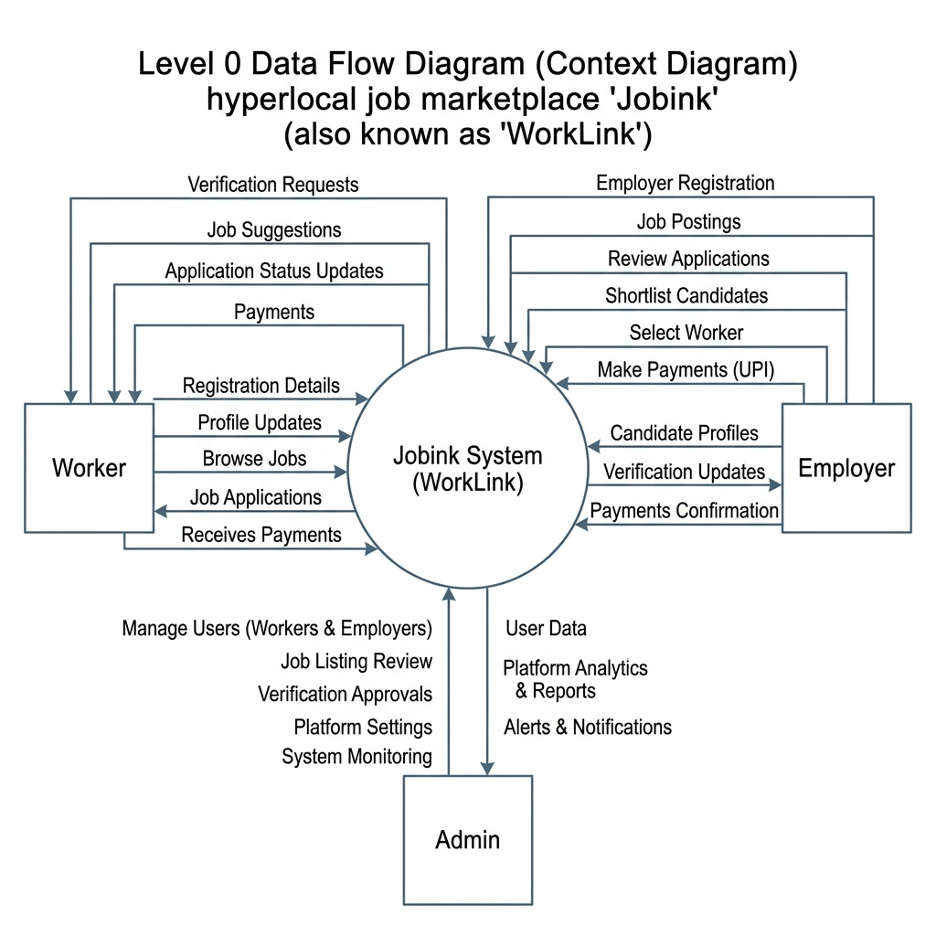

3.2 ER Diagram
Entity-Relationship Diagram:
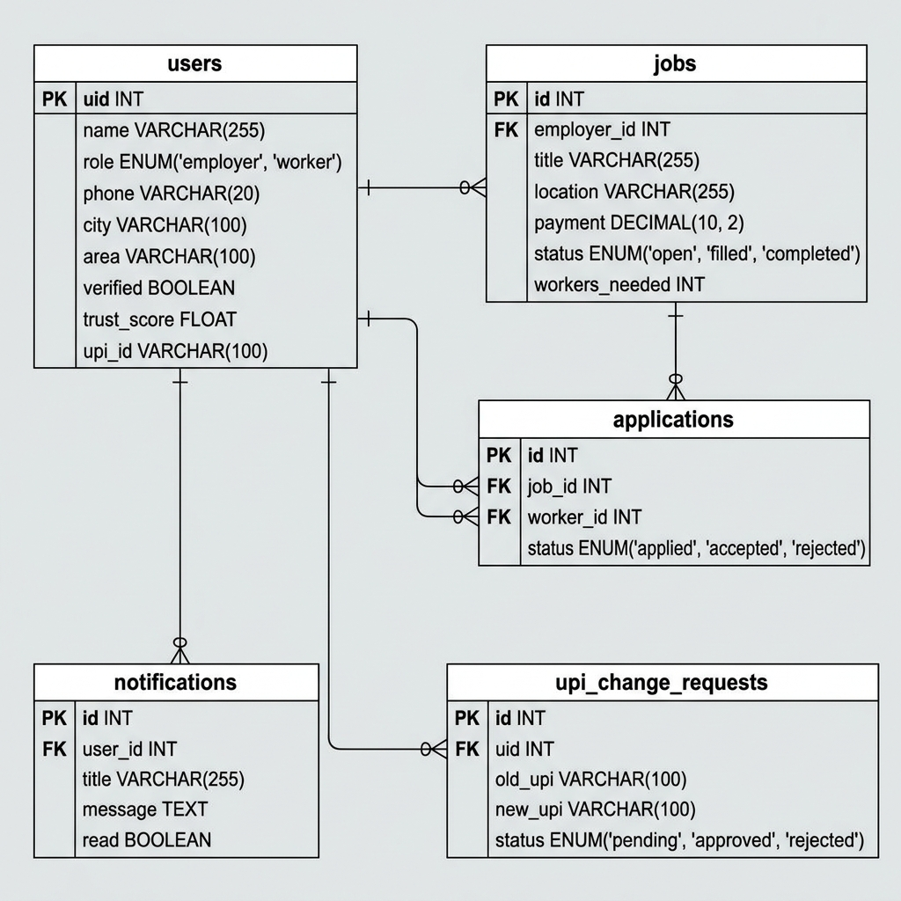

3.3 Table Design
Table 4: users table
Column Name | Data Type | Constraint | Description
uid | VARCHAR(255) | PRIMARY KEY | Unique Firebase user identifier
name | VARCHAR(255) | NOT NULL | Display name of the user
role | VARCHAR(50) | CHECK(role IN (worker, employer, admin)) | User platform role
phone | VARCHAR(20) | UNIQUE, NOT NULL | Mobile number for authentication
city / area | VARCHAR(100) | NOT NULL | Local geography filtering tags
verified | BOOLEAN | DEFAULT FALSE | Overall profile validation flag
upi_id | VARCHAR(255) | NOT NULL | Worker UPI ID for direct payments
trust_score | INT | DEFAULT 20 | Reliability metric (0 to 100)
availability | BOOLEAN | DEFAULT TRUE | Worker availability status
Table 5: jobs table
Column Name | Data Type | Constraint | Description
id | SERIAL | PRIMARY KEY | Auto-incrementing job identifier
employer_id | VARCHAR(255) | REFERENCES users(uid) | Job poster reference
title | VARCHAR(255) | NOT NULL | Job posting title
payment | NUMERIC(10,2) | NOT NULL | Payout amount for the job
status | VARCHAR(50) | CHECK(status IN (open, assigned, completed)) | Current job stage
city / area | VARCHAR(100) | NOT NULL | Job location tags
workers_needed | INT | DEFAULT 1 | Number of worker openings
Table 6: applications table
Column Name | Data Type | Constraint | Description
id | SERIAL | PRIMARY KEY | Application identifier
job_id | INT | REFERENCES jobs(id) | Reference to job posting
worker_id | VARCHAR(255) | REFERENCES users(uid) | Reference to worker profile
status | VARCHAR(50) | CHECK(status IN (pending, selected, rejected)) | Application selection status
Table 7: notifications table
Column Name | Data Type | Constraint | Description
id | SERIAL | PRIMARY KEY | Notification ID
user_id | VARCHAR(255) | NOT NULL | Target user UID
title | VARCHAR(255) | NOT NULL | Alert title
message | TEXT | NOT NULL | Notification body text
read | BOOLEAN | DEFAULT FALSE | Read status flag

CHAPTER 4

MODULES

4.1 Module Description
The WorkLink (Jobink) platform is structured into eight modules, each handling a distinct functional area:
- Module 1 — Authentication & Onboarding: User registers via mobile phone OTP using Firebase Auth. On first sign-in, onboarding requires selecting a role (Worker or Employer) and inputting locations (City, Area) and UPI IDs.
- Module 2 — Worker Feed & Dashboard: Workers view open job postings in their specific location. Features in-memory caches in db.js to avoid double-fetching and infinite scroll using IntersectionObserver.
- Module 3 — Employer Dashboard: Employers post jobs with payments, locations, and descriptions, and monitor applicant count.
- Module 4 — Applications & Hiring Flow: Employers evaluate applicant worker cards displaying selfie approvals, UPI ID strings, and trust scores. Employers select workers, setting job and application statuses to assigned.
- Module 5 — WhatsApp & Call Integration: Once assigned, direct buttons dynamically enable phone calls and WhatsApp messaging triggers, connecting both parties without platform middleman channels.
- Module 6 — Payment & Job Completion: Employers pay workers directly using UPI IDs and mark jobs as completed. Completion triggers increments of completed jobs count, raising the worker's trust score.
- Module 7 — Identity Verification (Admin): Admin panel allows managers to approve or reject pending selfies and UPI change requests, updating verificationStatus and verified flags in Firestore.
- Module 8 — Real-Time Notification System: Firebase snapshot listeners track document updates, pushing real-time push notifications on assignments, selections, and payments.

CHAPTER 5

TESTING

5.1 Unit Testing
Individual modules were validated in isolation using simulated inputs:
Test Case | Module | Input | Expected Output | Result
TC-01 | Authentication | Valid phone number + OTP | Logs in, redirects to dashboard | ✅ Pass
TC-02 | Job Posting | Employer with Trust Score 30 posts ₹5000 job | Blocks posting (requires score >60) | ✅ Pass
TC-03 | Job Feed | Worker in City "Coimbatore", Area "Kuniamuthur" | Loads only Coimbatore/Kuniamuthur jobs | ✅ Pass
TC-04 | Application | Worker applies for open job | Application document created, job applicant count increments | ✅ Pass
TC-05 | Hiring Flow | Employer selects worker | Job status changes to "assigned", worker receives notification | ✅ Pass
TC-06 | Communication | Worker clicks WhatsApp icon | Launches WhatsApp URL with prefilled job text | ✅ Pass
TC-07 | UPI Payment | Employer pays worker directly and completes job | Completed jobs count increments, trust score rises | ✅ Pass
TC-08 | Admin Selfie | Admin approves pending user selfie | verified changes to true, trust score increases by 20 | ✅ Pass

5.2 Integration Testing
Integration tests validated database syncing, image resizing, and security triggers. Image compression pipelines were tested to convert uploaded JPEG files to 0.6 quality WebP client-side, cutting network load by 40% (averaging <100KB per file). Query caching and clearCache hooks were verified to correctly invalidate stale listings on job submissions and worker applications.

5.3 Security Testing
Verified the security barriers in firestore.rules. Row Level Security policies enforce:1. Non-logged-in users cannot read/write database documents. 2. Employers cannot modify the job status field directly (only Cloud Functions or assigned updates). 3. Users can only update their own notifications and profiles.

5.4 Usability Testing
Tested UX scaling on mobile layouts. Verified that buttons, text fields, and interactive cards meet the Android touch target size recommendations (minimum 44x44px), viewport scaling fits cover layouts, and infinite scrolling footer loads jobs smoothly without lag.

CONCLUSION

The Jobink local jobs platform successfully connects local employers with job seekers through a simple, fast, and reliable digital platform. By leveraging Firebase for real-time data management and optimized mobile performance techniques, the system delivers a smooth user experience across devices. Features such as employer verification, location-based job discovery, and a trust-based hiring ecosystem help create a secure and efficient environment for local employment. The platform demonstrates how technology can simplify the hiring process, increase job accessibility, and support the growing demand for flexible and part-time work opportunities within local communities.

FUTURE SCOPE
• Implement intelligent matching algorithms to automatically recommend relevant jobs to workers based on skills, experience, location, and preferences.
• Integrate trusted payment gateways to enable secure and seamless transactions between employers and workers directly within the platform.
• Add interactive map features for job discovery, worker tracking, distance calculation, and navigation to job locations.
• Introduce a built-in messaging platform that allows employers and workers to communicate instantly without relying on external applications.
• Insights on job applications, hiring trends, worker performance, and platform activity for employers and administrators.

APPENDIX

A. Sample Code

A.1 Firestore Security Rules (firestore.rules)

rules_version = '2';

service cloud.firestore {

match /databases/{database}/documents {

function isLoggedIn() {

return request.auth != null;

}

match /users/{userId} {

allow read, write: if isLoggedIn() &&

request.auth.uid == userId;

}

match /jobs/{jobId} {

allow read: if isLoggedIn();

allow create: if isLoggedIn();

allow update: if isLoggedIn();

allow delete: if isLoggedIn();

}

match /applications/{appId} {

allow read, create, update: if isLoggedIn();

}

match /disputes/{disputeId} {

allow read, write: if isLoggedIn(); }}}

A.2 Client-Side Query Cache Layer (db.js)
const profileCache = new Map();
const jobsCache = new Map();
export const clearCache = () => {
profileCache.clear();
jobsCache.clear();
};
export const calculateTrustScore = (user) => {
let score = 0;
if (user.phoneVerified) score += 20;
if (user.upiVerified) score += 20;
if (user.selfieVerified) score += 20;
return Math.min(score, 100);
};
export const updateVerification = async (user) => {
const verified =
user.phoneVerified &&
user.upiVerified &&
user.selfieVerified;
return {
verified,
trustScore: calculateTrustScore(user)
};
};

A.3 Capacitor Android Configuration (capacitor.config.json)
{
"appId": "com.jobink.app",
"appName": "Jobink",
"webDir": "dist",
"bundledWebRuntime": false,
"server": {
"androidScheme": "https",
"allowNavigation": [
"*.firebaseapp.com",
"*.googleapis.com"
]
},
"android": {
"allowMixedContent": true,
"captureInput": true,
"webContentsDebuggingEnabled": true
}
}

B. Screenshots
- 1. Mobile OTP Authentication - OTP numeric inputs and invisible Recaptcha.
- 2. Onboarding Registration screen - Localized area search selection and UPI ID inputs.
- 3. Worker Dashboard Feed - Localized jobs stream with inline scrolling.
- 4. Employer Dashboard - Job creation form and active postings applicant counts.
- 5. Applicant Review Modal - Selfie photo previews, trust score progress bar, and UPI validation buttons.
- 6. Direct Communication - Direct dialer links and quick WhatsApp chat icons.
- 7. Admin Verification Queue - Flagged profiles, pending selfies, and UPI update approvals.
- 8. Real-time Notifications - Inbox alerts page and header dropdown list.

